Social Sport Ladder
User Guide
Login Page

Starting the App
Note that the app is actually a web page that looks like an app. Using any modern web browser such as Safari, or Chrome and enter this URL:
https://social-sport-ladder.web.app

Android Chrome
For Androids you can use the 3 dots menu in the top right of Chrome and select “Add To Home Screen”
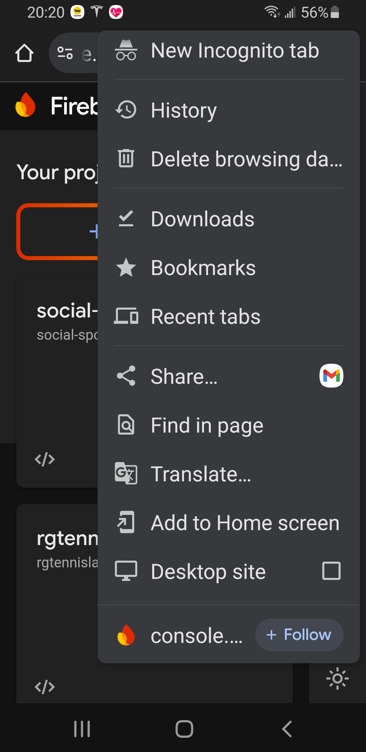

this will put an Icon on your phone that will launch the app.
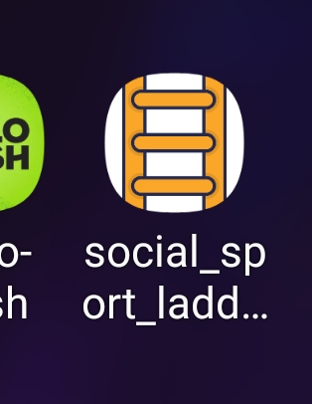

Iphone Safari
Open Safari, go to the website you want to add, tap the menu bar, scroll down, and tap Add to Home Screen. If you don't see Add to Home Screen, you can scroll to the bottom of the list, tap Edit Actions, then tap Add to Home Screen.

Logging In
Once you log in once you normally do not have to log in again, but there are some exceptions, so please remember your email and password.
The email address you use MUST match the email address that your administrator registered you with. Your email address is how you are identified in the app, but your email address is not shown to other players. Instead your administrator has entered a name to display. If you do not like that name you can ask your administrator to change it. If you need to change your email address then the administrator has to delete your user and create a new one.

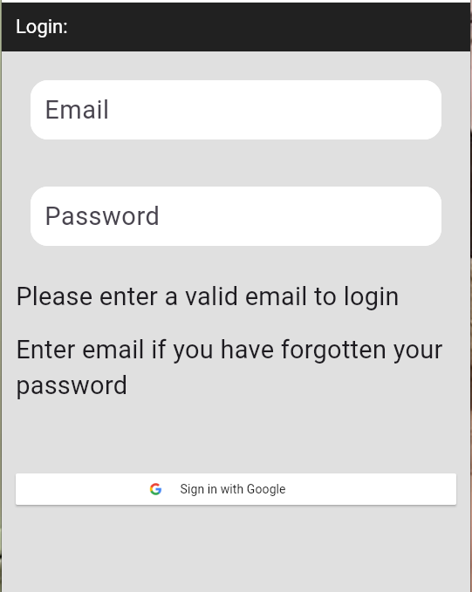
Fields

Email Text Entry Field
- You have a choice of how you login. You can use the simple button below labelled “Sign in with Google” if you have an email managed by Google. Most of these end in @gmail.com but there are many that end with something different.
- Enter your email address here. Note that this is the email address that you used to register for this ladder. It is the one that your administrator entered into the app. If the app does not recognize this as an email that it recognizes you will get an error.
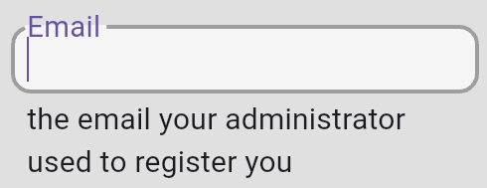

- Invalid email format. As you are typing the error message will display “Invalid email format” until you have typed in most of your email address. This is to warn you if you type something not appropriate for this field like your name.
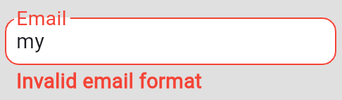

- After email is entered. Once this is entered you can start entering the password
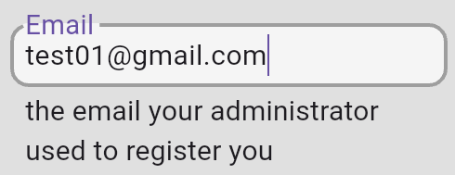

Password Text Entry Field
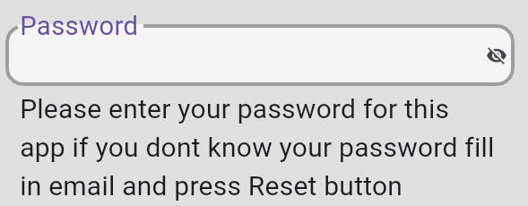

- Reset Button. If you do not know your password (or you have forgotten it) then you do not enter anything in this field and instead look for the button labelled “Send Password Reset Email” below.
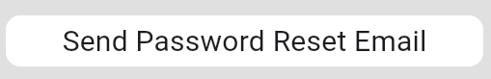

- Too short. The password must be at least 6 characters long. If your password is not that long then you need to use the “Send Password Reset Email” and change it to a longer one.
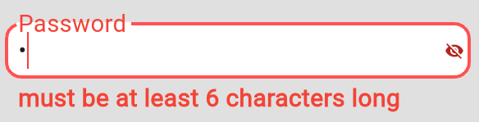
- Reveal Password. By default your password is obscured to prevent someone from looking over your shoulder and seeing your password. But is you want to see what you have entered you can click on the icon that looks like an eye with a line through it on the right side to see what you have typed:


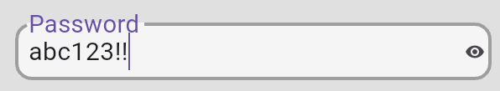
- Sign in with Email, once you have your password entered. If this button is not showing then you have not entered both your email and your password.
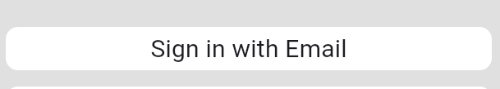

“Send Password Reset Email” Button
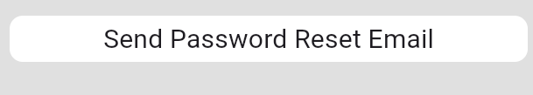
- Hidden. This button is only visible if you have entered a valid email in the field above.
- This button will send an email to the address that you entered above in the “Email” field.
- This reset email is only valid for 1 hour. But no worries, if it times out then you can just press this button again and get another email.

“Sign in with Google” button
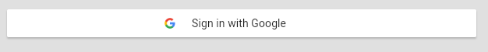
- No new password required! This button will only work if you have an email managed by Google. Most of these end in @gmail.com but there are many that end with something different.
- Note that if you want this to work then your administrator had to use your gmail address when you registered. This will not work with just any gmail account.

Errors displayed in Red
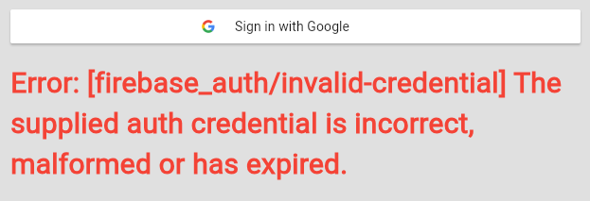
- If the login failed this is where the error message will be displayed. This is the most common one, it indicates that EITHER your email address or your password is incorrect. It does not tell you which on for security reasons. (otherwise hackers could tell if you have an account or not)

